1. **Data preparation**

**Numpy:** allows us to work with arrays.

**Matplotlib:** allows us to plot charts and graphs

**Pandas:** allows us to plot the dataset and create a matrix of features or preprocess your dataset

**Features/independent variables –** variables containing the properties that you will use to make a prediction which is your **dependent variable vector.**

**iloc (locate indexes) –** take the indexes of the columns and rows we want to extract from the dataset. A trick to take all the rows is by using a **colon** (**:**) which stands for a range. To separate the rows from the columns, use a **comma**

A range in python includes the lower bound but includes the upper bound

dataset.iloc[:, :-1].values : in iloc the order is rows, columns

**ct = ColumnTransformer(transformers=, remainder=”passthrough”) : transformers-** Specifies the kind of transformation we want to do and on which indexes of the columns we want to transform, remainder – specify that we actually want to keep the columns that won’t be applied some transformations. **Passthrough** enables us to **not only** keep the three columns resulting from one hot encoding eg 100, 010, 001

**fit_transform** method doesn’t return it’s output as a numpy array whereby models as a must need the data to be in the form of a numpy array, so you use

**Feature scaling**: scaling all your variables or features to make sure they all take values in the same scale.

Don’t do feature scaling before splitting the dataset to prevent information leakage to the test set

**Note: Standardization works all the time –** puts values of features between -3 and +3 or -2 and +2, while **normalization works when you have a normal distribution of your values –** puts values between 0 and 1

1. **Simple Linear Regression – one independent variable / feature vector**

With **regression** you predict a continuous value while with classification you predict a category.

**The best regression line** is the one where the **SUM(y1-y1`)2** is minimized

**Note: (y1-y1`) is the residual that is the difference between the actual point and the predicted point**

1. **Multiple Linear Regression**

**Anscombe’s quartet:** You can’t simply apply linear regression, you must make sure your dataset is fit for using linear regression.

**Assumptions of linear regression**

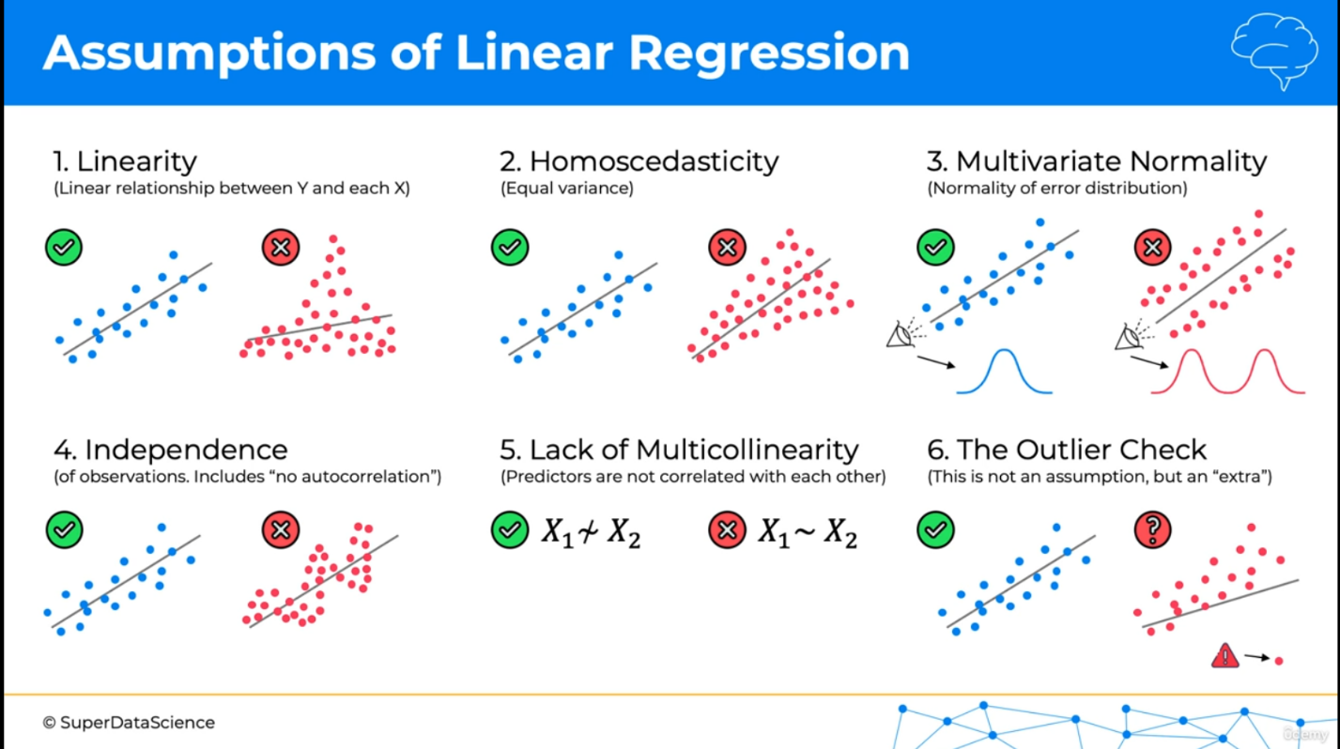

**Independence –** shouldn’t see a pattern in our data eg forex data

**When** you have categorical column data as one of your independent variables, then it’s necessary to use **Dummy variables.**

**Multicollinearity:** situation where one or more independent variables predict one another

**Whenever you’re building a model** only include one dummy variable

**Statistical significance**

**5 methods of building models**

1. All-in
2. Backward Elimination
3. Forward selection
4. Bidirectional Elimination
5. Score comparison

**NOTE:** Stepwise regression refers to 2, 3, and 4 and sometimes just 4.

1. **All-in** – use all your independent variables

**When would you do this**;

* **Prior knowledge**
* **You have to**
* **Preparing for backward Elimination**

1. **Backward Elimination**

**Step 1.** Select a significance level to stay in the model eg SL = 0.05

**Step 2.** Fit the full model with all possible predictors

**Step 3.** Consider the predictor with the highest P-value. If P > SL, go to STEP 4, otherwise go to FIN (finish ie model is ready)

**Step 4.** Remove the predictor

**Step 5.** Fit model without this variable

**After step 5, go back to Step 3**

1. **Forward Selection**

**Step 1.** Select a significance level to enter the model (e.g SL = 0.05)

**Step 2.** Fit all simple regression models y-xn Select the one with the lowest P-value

**Step 3.** Keep this variable and fit all possible models with one extra predictor to the one you already have

**Step 4.** Consider the predictor with the lowest P-value. If P < SL, go to STEP 3, otherwise go to FIN: Keep the previous model

1. **Bidirectional Elimination**

**Step 1:** Select a significance level to enter and to stay in the model

**Step 2:** Perform the next step of Forward selection (new variables must have: P < SLENTER to enter)

**Step 3:** Perform ALL steps of Backward Elimination (old variables must have P < SLSTAY o stay)

**Step 4:** No new variables can enter and no old variables can exit

1. **All Possible Models**

**Step 1:** Select a criterion of goodness of fit (e.g. Akaike criterion)

**Step 2:** Construct All possible regression models: 2N – 1 total combinations

**Step 3:** Select the one with the best criterion

**NOTE:** In multiple linear regression there is absolutely no need to apply feature scaling and also to check for the assumptions of linear regression